**OUTPUTS**

**EXERCISE – 1**

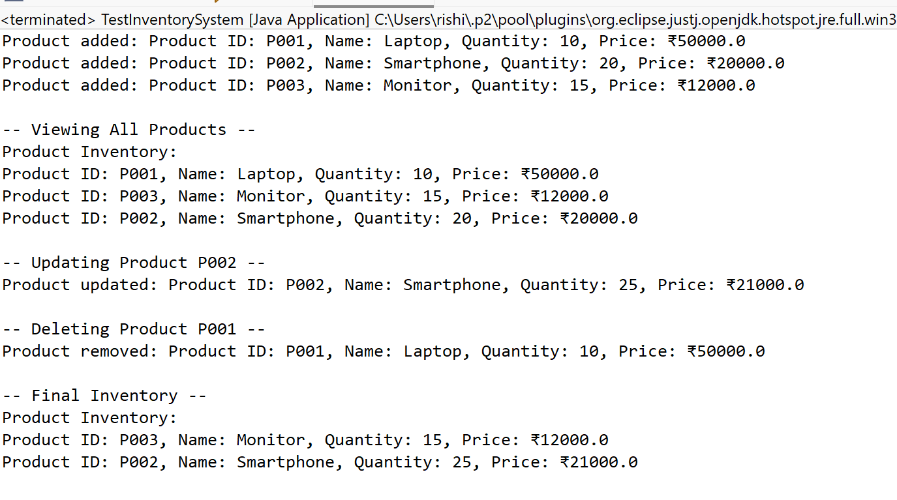

**EXERCISE – 2**

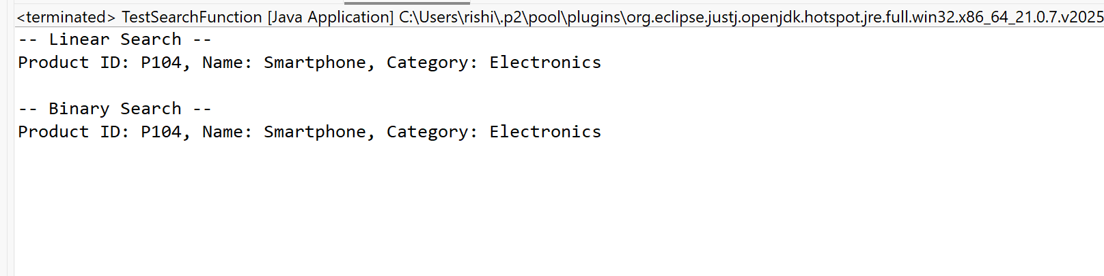

**EXERCISE – 3**

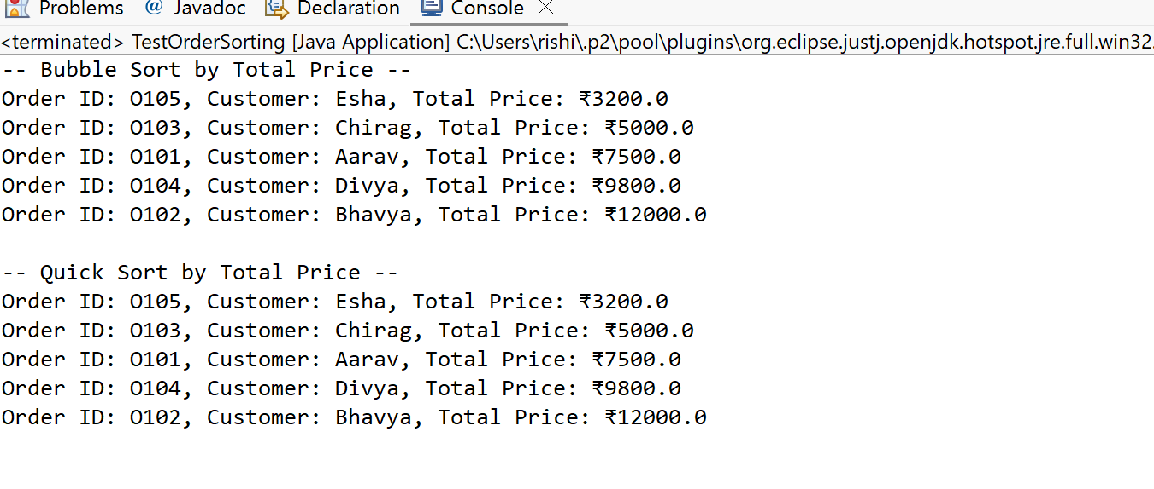

**EXERCISE – 4**

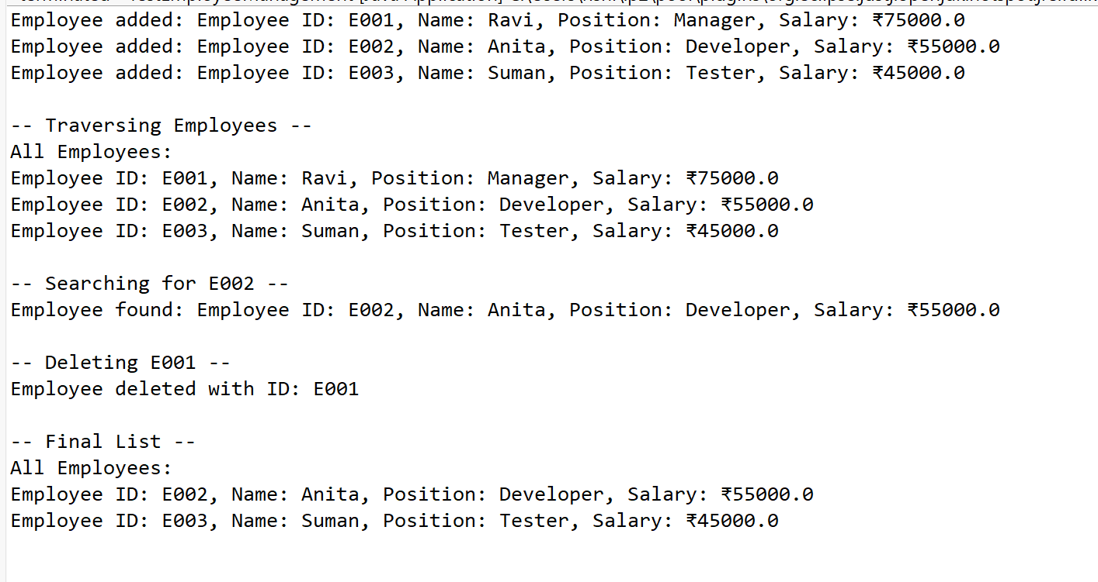

**EXERCISE – 5**

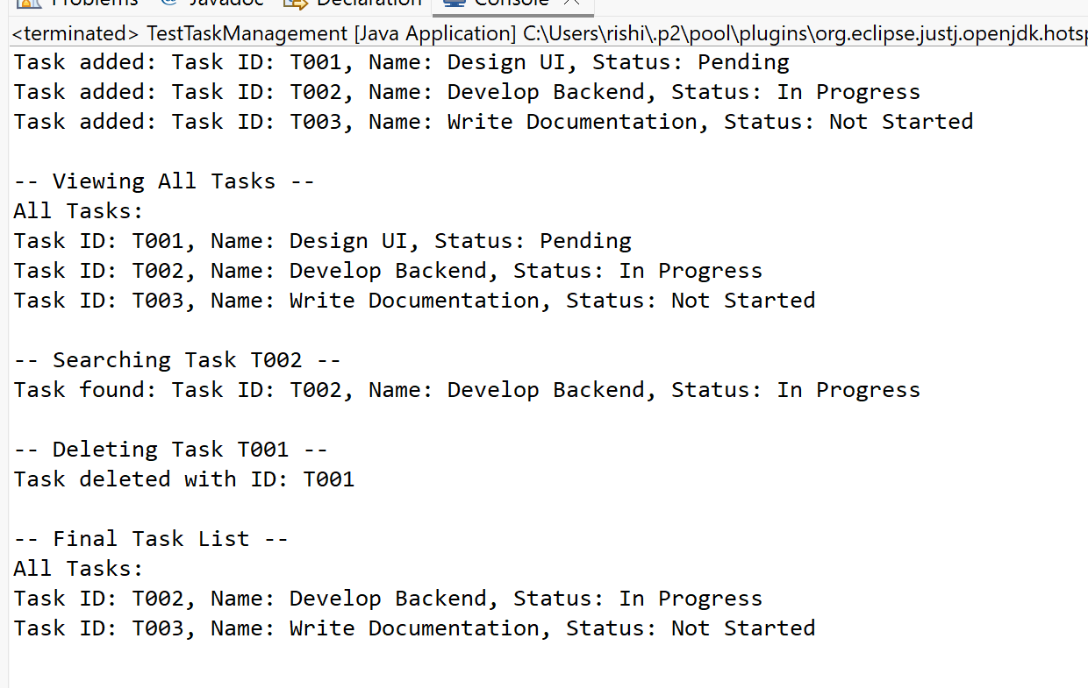

**EXERCISE – 6**

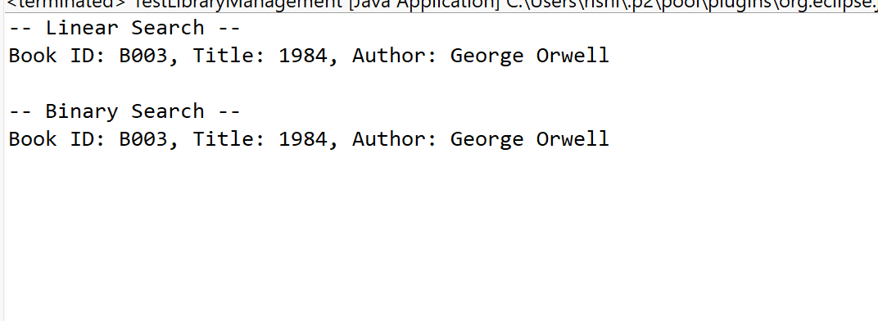

**EXERCISE – 7**

